AD5626 Breakout – 12-bit nano DAC
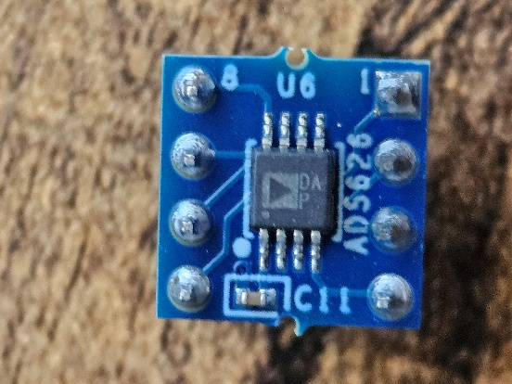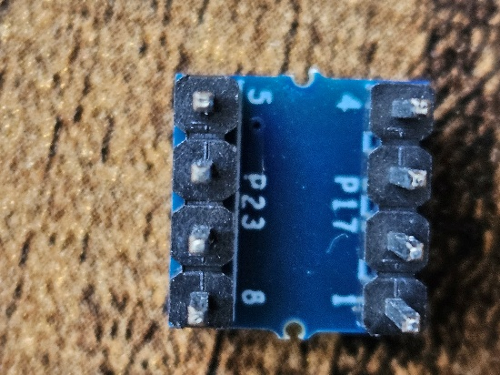
The AD5626 uses a 5 V supply, accepts serial data through SDIN, SCLK, CS, and LDAC, and produces 0–4.095 V at 1 mV per code. Pulling CLR low forces the output to zero scale.

Pin | Function | Connection for ESP32
1 | LDAC | ESP32 GPIO, or hold low for immediate updates
2 | SCLK | ESP32 SPI clock
3 | SDIN | ESP32 MOSI
4 | GND | Common ground
5 | VOUT | DAC analog output
6 | CLR | ESP32 GPIO; active low
7 | CS | ESP32 chip-select GPIO
8 | VDD | Regulated 5 V

Suggested first wiring
AD5626 pin 8 VDD → ESP32 board 5 V / VIN supply
AD5626 pin 4 GND → ESP32 GND
AD5626 pin 2 SCLK → ESP32 SPI SCK
AD5626 pin 3 SDIN → ESP32 SPI MOSI
AD5626 pin 7 CS → dedicated GPIO
AD5626 pin 1 LDAC → dedicated GPIO or GND
AD5626 pin 6 CLR → dedicated GPIO with pull-up to 3.3 V
AD5626 pin 5 VOUT → oscilloscope input

A practical first configuration is to connect LDAC permanently to ground. Then each completed serial write updates the output automatically. Later, controlling LDAC separately would let us synchronize updates more precisely.
For CLR, I would use:
CLR → 10 kΩ pull-up to 3.3 V
CLR → ESP32 GPIO
The ESP32 can then pull it low to force 0 V. The pull-up prevents it from floating.
Also place a 0.1 µF ceramic capacitor between pins 8 and 4, physically close to the breakout. The board appears to contain one small capacitor already, but adding local breadboard decoupling is still inexpensive insurance.

